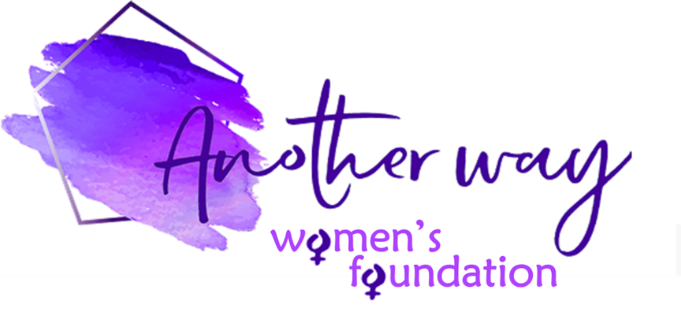

Another Way Women’s Foundation £1000 for 1000 Words Grant – Application Form

Name of organisation: | Address of organisation:
Registered charity number (if applicable): | Address or location of project:  (if different from above)
Contact name/s: | Contact phone/s:  Contact email:
Organisation website/social media links if you have them:

Briefly tell us about your organisation:

In 1000 words max, tell us about your idea, how the £1000 grant would be spent and how you think it will positively impact on women in need and/or the community:

Please provide clear project objectives that are Specific, Measurable, Achievable, Relevant and Time-based:
These objectives will be used to assess the project’s success at regular project reviews

If your application is successful, we would require you to provide regular written updates on a Quarterly basis on the project progress, along with the successes versus the agreed objectives. Also, we require testimonials and pictures to be provided, where possible, for us to use on our website to publicise your cause. Please state that you agree to these conditions – tick box: YES NO

We appreciate the need for confidentiality and should you have concerns about this, please outline these below and we will ensure to take this into consideration. It should also be noted that we will always abide by all GDPR regulations.

Signed on behalf of the above organisation: | Date of signature:

While we would like to respond to all applicants in person, this might not always be possible and Another Way Women’s Foundation reserves the right to decline applications without reason.

Unsuccessful applicants may apply again – please check our website for the next deadline.

Should the projects not be completed within the outlined timeframes or metrics we reserve the right for full or partial repayment of the grant, and by submitting this application it will be assumed that you agree to this term.

COMPLETED FORM SHOULD BE EMAILED TO: hello@anotherwaywf.org

