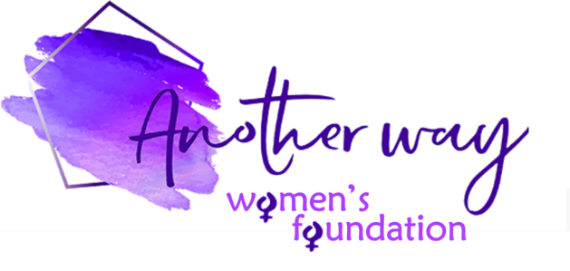

Another Way Women’s Foundation Grant – Application Form – January 2026

Thank you for applying for a foundation grant.
All applications must be in line with and supportive of our charitable purpose – which is
to enable a brighter and fairer future for women and girls through financial support, education, empowerment and advancement, and to accelerate gender equality, effect system change and advance women’s lives, sustainably, at both an individual and community level – as well as our values and ethos – which are to be empowering & enabling, community- and people-centric, passionate & inspiring, and trusted & respectful.

To enable us to consider your application you must fully complete the application form, giving clear, detailed and specific responses to ALL of the questions and adhering to the MAX word counts please.
Your application should NOT EXCEED 4 A4 pages in Aptos 11 font.
Failure to comply with the instructions means that we will not be able to consider your application.

Name of organisation: | Address of organisation:
Registered charity number (if applicable): | Address or location of project:  (if different from above)
Contact name/s: | Contact phone/s:  Contact email:
Organisation website/social media links, if you have them:

Please tell us about YOUR ORGANISATION – you must include ALL the following information:
(i) What is your charitable purpose, what services do you provide, and to whom? (200 words MAX)

(ii) Is your organisation UK-based? YES NO

(iii) Do the values and ethos of your organisation match those of AWWF? YES NO

(iv) Approximately how many women/girls do you support each year?

(v) Is your organisation secular or affiliated to a religious organisation?
Secular Affiliated to a religious organisation

(vi) How many employees does your organisation have?

(vii) How many volunteers does your organisation have?

(viii) How many employees in your organisation earn £60,000+?

(ix) What is the annual salary of the CEO (or equivalent role)?

Briefly, tell us about THE PROPOSED PROJECT AND ITS IMPACT – you must include ALL the following information:

(i) How much money are you applying for? Grants are normally in the region of £500 to max £5,000

(ii) What is the project and/or service(s) that you would like grant support for, or are you applying for an unrestricted grant? (300 words MAX)

(iii) What percentage of the overall project and/or service(s) cost would this grant be funding?

(iv) Specifically, how many women/girls will benefit as a result of this grant?

(v) When will the project/service(s) start and end?

(vi) How will the money be spent? Please provide a detailed breakdown of costs, as well as a proposed timetable for when the money will be spent

(vii) How do you envisage the grant having a positive, measurable and sustainable impact on women/girls in need and/or the community as a whole? Will there be any system change? What will success look like? (200 words MAX)

(viii) How will you measure/assess impact?

(ix) Will the project and/or service(s) address a specific high need and, if so, what is it (ie, filling a need or gap in an under-represented community and/or an under-funded area)?

(x) Is the project and/or service(s) sustainable and, if so, how? And what is the funding exit strategy?

(xi) Is this a pilot? Or has there been a pilot preceding this project? If so, please provide impact stats for this

(xii) Will the proposed project and/or service(s) be delivered in the UK? YES NO

(xiii) Is the project and/or service(s) not for profit and not for self-benefit? YES NO

(xiv) In the case of a grant application to support employment of an individual(s), could the charitable purpose be fulfilled on a voluntary basis instead? YES NO
And could the remuneration be deemed excessive in any way? YES NO

Please tell us briefly about THE PROPOSED PROJECT OBJECTIVES – provide clear objectives that are Specific, Measurable, Achievable, Relevant and Time-based (these objectives will be used to assess the project’s success at regular project reviews):

Please provide brief details of what funding have you had up until now? (eg. Government grants, fundraising, private donations, etc):

If your application is successful, we would require you to provide regular written updates on a Quarterly basis on the project progress, along with the successes versus the agreed objectives. Also, we require testimonials and pictures to be provided, where possible, for us to use on our website to publicise your cause. Please state that you agree to these conditions: YES NO

We appreciate the need for confidentiality and should you have concerns about this, please outline these below and we will ensure to take this into consideration. It should also be noted that we will always abide by all GDPR regulations.

Signed on behalf of the above organisation: | Date of signature:

While we would like to respond to all applicants in person, this might not always be possible and Another Way Women’s Foundation reserves the right to decline applications without reason.

Unsuccessful applicants may apply again – please check our website for the next deadline.

Should the projects not be completed within the outlined timeframes or metrics we reserve the right for full or partial repayment of the grant, and by submitting this application it will be assumed that you agree to this term.

THE COMPLETED FORM SHOULD BE EMAILED TO: hello@anotherwaywf.org

