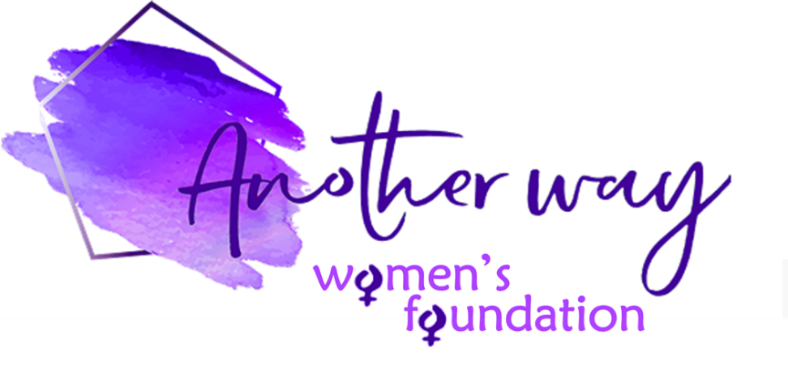

Another Way Women’s Foundation Grant – Application Form

Thank you for applying for a foundation grant.
All applications must be in line with and supportive our of charitable purpose – which is to support the relief and need, education, empowerment and advancement of women – as well as our values and ethos.

To enable us to consider your application you must fully complete the application form, giving clear, detailed, measurable project objectives. Without this information we will not be able to consider your application.

Name of organisation: | Address of organisation:
Registered charity number (if applicable): | Address or location of project:  (if different from above)
Contact name/s: | Contact phone/s:  Contact email:
Organisation website/social media links if you have them:

Tell us about your organisation:

Tell us about the project:

Tell us when the project will start/end and any milestones in delivery:

Please provide clear project objectives that are Specific, Measurable, Achievable, Relevant and Time-based:
These objectives will be used to assess the project’s success at regular project reviews

How much money are you applying for? Grants are normally in the region of £500 to max £5,000

Please explain in detail how the money would be spent and provide a detailed breakdown of costs, as well as a proposed timetable for when the money will be spent:

How do you envisage the grant having a positive, measurable and sustainable impact on women in need and/or the community? (max 400 words)

What funding have you had up until now? (eg. Government grants, fundraising, private donations, etc – please give details):

If your application is successful, we would require you to provide regular written updates on a Quarterly basis on the project progress, along with the successes versus the agreed objectives. Also, we require testimonials and pictures to be provided, where possible, for us to use on our website to publicise your cause.
Please state that you agree to these conditions – tick box: YES NO

We appreciate the need for confidentiality and should you have concerns about this, please outline these below and we will ensure to take this into consideration. It should also be noted that we will always abide by all GDPR regulations.

Signed on behalf of the above organisation: | Date of signature:

While we would like to respond to all applicants in person, this might not always be possible and Another Way Women’s Foundation reserves the right to decline applications without reason.

Unsuccessful applicants may apply again – please check our website for the next deadline.

Should the projects not be completed within the outlined timeframes or metrics we reserve the right for full or partial repayment of the grant, and by submitting this application it will be assumed that you agree to this term.

COMPLETED FORM SHOULD BE EMAILED TO: hello@anotherwaywf.org

